TBBT Assignment

3 success stories of Digital Transformation Stories

1.McDonald’s:

McDonald’s, founded in 1940 in California, is a leading global fast-food chain known for its iconic Big Mac and fries. It operates thousands of restaurants worldwide, offering consistent quality and quick service. The menu has expanded over time to include breakfast items, salads, and beverages, with ongoing innovations to adapt to customer preferences.

Technology used:

McDonald’s uses technology to enhance its service by offering a mobile app for ordering, self-service kiosks in restaurants, and digital screens for updated menus. They partner with delivery services, use advanced kitchen equipment for efficiency, and analyze data to improve customer satisfaction.

Before and After Story

Before: McDonald’s began in 1940 as a small California drive-in with a simple menu and traditional counter service, focusing on fast and consistent food.

After: McDonald’s has become a global leader in fast food, using technology like mobile apps, self-service kiosks, and digital menu boards. They also offer delivery, advanced kitchen equipment, and use customer data to enhance their offerings, continuously innovating to meet modern preferences.

Strategies used

McDonald’s stays successful by offering consistent food quality, fast service, and a frequently updated menu. They provide convenient ordering options through apps, kiosks, and delivery. By adapting their menu to local tastes and maintaining a strong, family-friendly brand, they attract and retain customers while staying competitive.

Challenges

McDonald’s faces challenges such as the need to offer healthier menu options, intense competition, and managing ingredient supplies and costs. They also need to address environmental concerns, adapt to changing customer preferences for digital and faster services, and navigate economic fluctuations affecting sales.

Why are Business Moving Towards Digital Transformation?

Businesses like McDonald’s are embracing digital transformation to streamline ordering and payment, boost efficiency, and understand customer preferences better. This helps them stay competitive, meet modern expectations, and improve overall operations and customer satisfaction.

2.Domino’s:

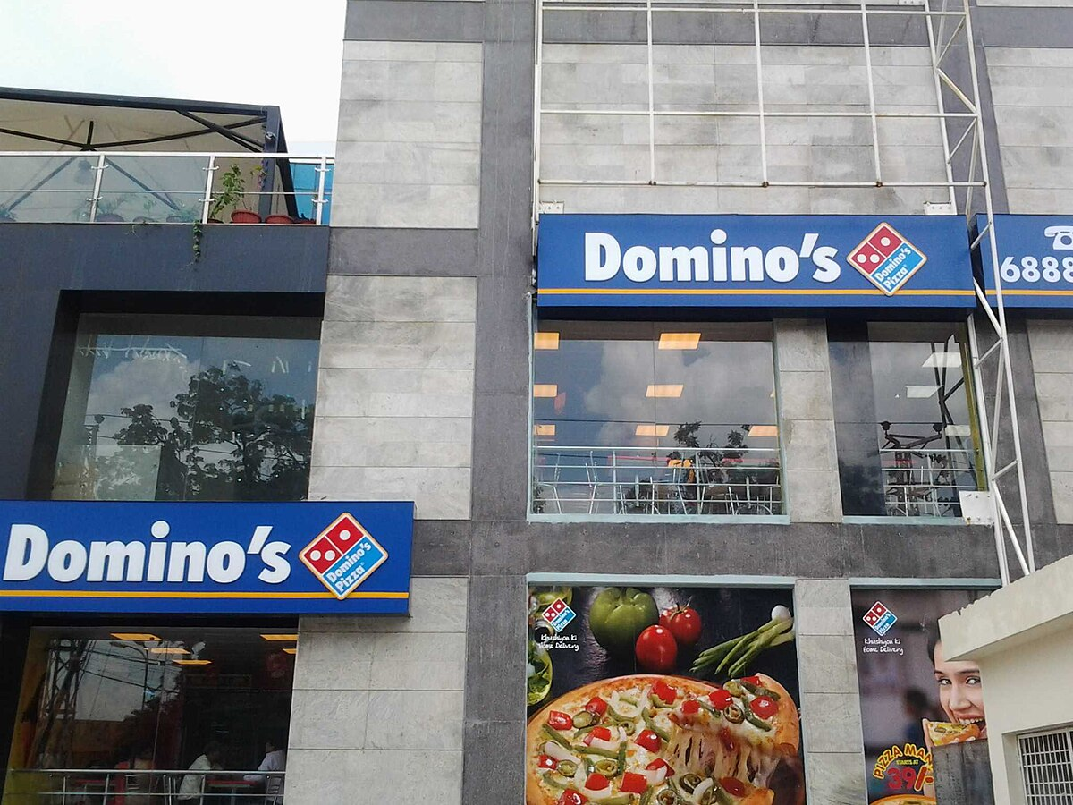Domino's is a popular pizza chain known for its wide variety of pizzas, pasta, and other menu items. Founded in 1983, it started as a small pizza place and has since grown into a global brand with thousands of locations around the world. Domino's is famous for its quick delivery service and custom pizzas made with fresh ingredients. They focus on providing fast, convenient meals and often offer special deals and promotions.

Technology used

Domino's uses technology to simplify ordering with its app and website, track deliveries in real-time with GPS, and ensure efficient cooking with advanced ovens. They also analyze data to better understand and serve customer preferences, making their service fast, accurate, and convenient.

Before and After Story

Before: Domino’s began in 1983 as a small pizza shop with phone orders and standard ovens, focusing on quick delivery and tasty pizzas.

After: Now a global pizza chain, Domino’s uses technology like mobile apps and real-time delivery tracking, advanced cooking equipment, and data analysis to make ordering and delivery more efficient and convenient.

Strategies used

Domino’s stays successful by simplifying ordering through apps and websites, offering real-time delivery tracking, ensuring fast delivery, using advanced cooking equipment, providing a diverse menu, and offering regular deals. These strategies ensure a smooth and satisfying customer experience.

Challenges

Domino’s faces challenges like standing out in a competitive market, maintaining consistent pizza quality, managing ingredient supplies and costs, adapting to changing food trends, and handling operational expenses. They need to continuously adapt to overcome these issues and stay successful.

Why are Business Moving Towards Digital Transformation?

Businesses like Domino’s are adopting digital transformation to make ordering and tracking easier, streamline kitchen operations, understand customer preferences through data, and manage delivery and inventory more efficiently. This helps them stay competitive, meet customer expectations, and run operations more smoothly.

3.Netflix:

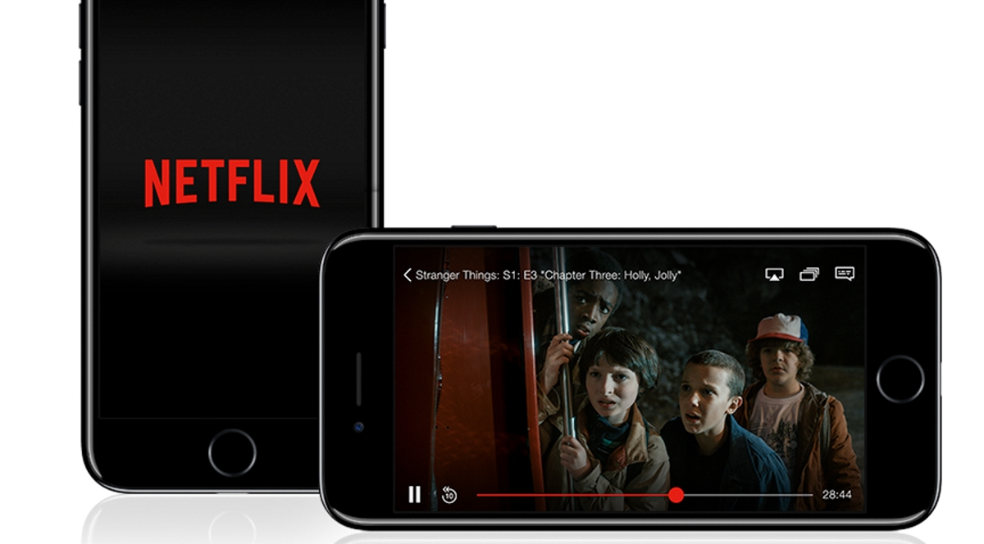Netflix is a popular streaming service founded in 1997, originally for DVD rentals but switched to online streaming in 2007. It offers a large library of movies, TV shows, and documentaries, including original content, which users can watch anytime on various devices.

Technology Used

Netflix uses technology to stream movies and shows over the internet, accessible on various devices. They use algorithms for personalized content recommendations, and rely on powerful servers and cloud storage for smooth delivery. Their technology also ensures high-quality streaming, even with different internet speeds.

Before and After Story

Before: Netflix began in 1997 as a DVD rental service, with customers ordering and mailing physical discs.

After: Since 2007, Netflix has become a global streaming leader, offering instant access to movies and TV shows online, producing original content, and changing how people enjoy entertainment.

Strategies used

Netflix stays successful by creating original content, recommending shows based on user preferences, tailoring content for different countries, offering an easy-to-use platform, providing flexible subscription plans, and continuously updating technology and content. These strategies ensure a compelling and enjoyable experience for viewers.

Challenges

Netflix faces challenges such as intense competition, high costs for quality content, balancing subscription prices, adapting to diverse global markets, and managing complex technology and data. They must continually adapt and innovate to overcome these issues and stay successful.

Why are Business Moving Towards Digital Transformation?

Netflix embraces digital transformation to offer instant content access, personalize recommendations, and manage streaming efficiently. This helps them stay competitive, handle many viewers, and adapt to changing trends, ultimately improving the viewing experience.